

INDUSTRY ANALYSIS: SOLAR

Batch: MPE-22

Year: 2018-20

Submitted By

Animesh Tamrakar

Nehalkumar Parate

Sparshita

Sunayana Sarma

Vikram BK

Narsee Monjee Institute of Management Studies

Executive Summary

Solar energy offers a clean, climate-friendly, very abundant and inexhaustible energy resource to mankind, relatively well-spread over the globe. India is blessed with 300 days of sunlight and a about 750 GW of solar energy per year. India has set an ambitious target of achieving 225 GW of renewable energy capacity by 2022. A large chunk of the Renewable Energy target is to be achieved via addition of solar capacity of 100 GW. As on June 2019, India has managed to achieve 31.5 GW of solar RE capacity which is far behind the target of 48GW set for march 2019. There is considerable growth in solar energy market due to subsidies & financial support, cheaper imported solar panels, advancement in manufacturing technologies and provisions to set up Solar Parks and Ultra Mega Solar Power Projects. A major chunk of the solar panel requirements in India is imported, mainly from China, Singapore and Malaysia. But, during the last year there is reversal in the growth of installed solar capacity and delay in solar projects mainly due to safeguard duty imposed by Government of India which has increased the prices of imported solar PV panels from China & Malaysia.

As per our study, we found that the solar industry can be divided into two primary sections based on the operations they deal with. The first section comprises of companies involved in researching & manufacturing solar panels and modules and the other part involves in implementing turnkey solar projects. We also found that the break-even period for Turnkey projects implementors are much higher than the solar product manufacturers. This is due to large investments needed in infrastructure setup and machinery procurement. The PE of the industry has improved from 5.7 to 9.9 over the past few years owing to the increased confidence shown by investors in the sector. The solar sector works in tandem with other RE sectors like wind and hydro. These hybrid sectors enjoy the same benefits as that of solar.

We have taken further analysis of Swelect, basically a solar product manufacturer and Adani Green, which is Turnkey project implementor for further analysis. We found that Adani Green is registering losses for the past few years mainly due to high finance cost while Swelect has been able to remain profitable and gives a ROE of 1% approximately. The sustainable growth rate (SGR) of Adani Green is -1.62 which shows that the company is not profitable and has to fund its investment projects through external funds. While Swelect has an SGR of 0.6 which means the company has enough funds to maintain a sustainable growth in future.

We have conducted a detailed Porter’s 5 forces analysis of industry along with Marketing, Sales forecasting, Operational and SWOT analysis of Adani Green and Swelect.

Porters 5 Forces and SWOT Analysis 4

Supplier Power 4

Threat of Substitution 5

Buyer Power 5

Threat of New entry 6

Competitive Rivalry 7

The Adani Green Advantage 8

Growth Strategy - doing the right things the right way 9

Financial Performance of Solar Industry 15

Capital Structure Analysis 15

Profitability of the Industry 16

Asset Turnover 18

Valuation Ratios 18

EBITDA Multiple Analysis 19

Liquidity Analysis 19

Working Capital Analysis - 20

CAGR Comparison Analysis of key financial metrics - 21

Revenue & Cost drivers for the future growth of solar industry - 22

Supply-Chain Management 29

Photovoltaic Supply Chain 30

Value Chain Analysis: 31

Operational Cost Structure: 32

Marketing Analysis 34

Swelect Marketing Analysis 34

Marketing Mix – 7 P’s 34

Segmentation, Targeting & Positioning 38

Ansoff Matrix 39

BCG Matrix 40

Adani Green (Adani Solar) Marketing Analysis 40

Marketing Mix – 4 P’s 41

# Porters 5 Forces and SWOT Analysis

The Indian government's goal for RE is ambitious: 175 GW by 2022. Now that RE has arrived, no one argues for the importance or efficacy of this. The market is ripening. It can be bidden or bidden for the procurement of panels, solar power stations or wind turbines by RE firms. Sparkling offices, new-age businesses, and flamboyant leaders are a norm in RE. It is no longer restricted to world of scientists and atavistic NGOs. It has definitely originated from the world of community groups working in small communities. RE facilities compete with coal power. The Ministry of Power now involves renewables — RE is no longer an outlying research field that is struggling to compete with the big boys.

## Supplier Power

The current manufacturing base for solar energy in India consists mainly of photovoltaic cells and modules with 1100 MW of cells and 1800 MW of solar modules with very limited and disparate fabrication and assembly capacities for solar thermal products and accessories. The raw material Input in PV cells consists of EVA, back-sheet, reflective glass, balance of system (BOS) for Solar Thermal and PV as also core machinery.

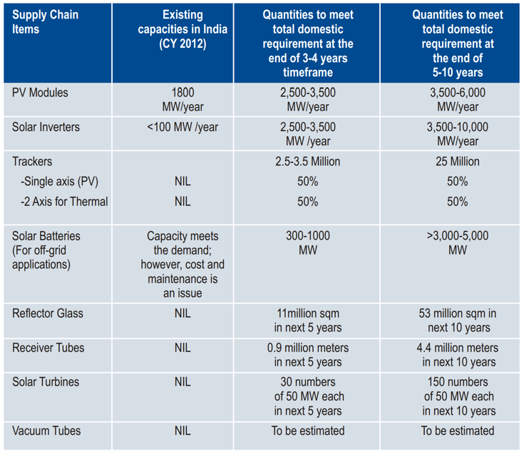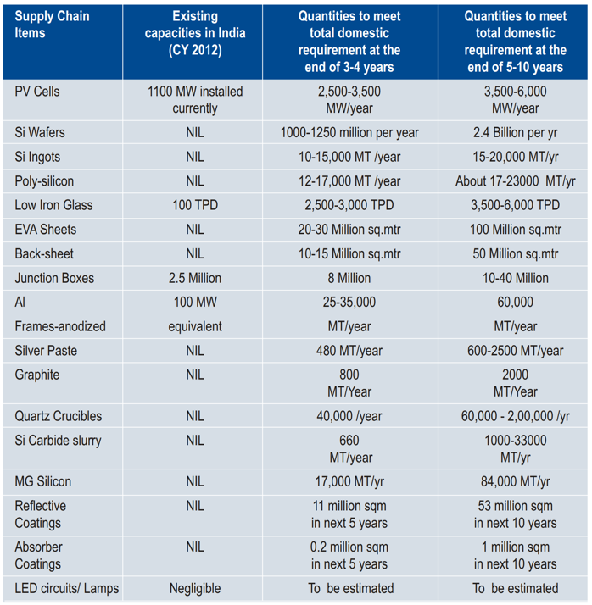

Supplier power can be segregated into suppliers for Solar Equipment manufacturers and inputs needed for Turnkey Project Implementers

* Material needed for manufacturing PV cells in India is mostly imported. Currently there is a 0% import duty charged for equipment imported.
* There are a number of suppliers spread globally but Chinese market forms a major chunk having 60-70% market share. They have plants with higher capacities and better technologies.
* Switching to indigenous manufacturing requires high capital requirement and high lead times due to inefficient logistics.
* Products from the solar supply chain are imported, which puts great pressure on our foreign exchange.
* Implementation of safeguard duty and incentive local manufacturing has promoted local companies to produce locally.

For Turnkey Project implementation

* Inputs consist of solar panels, Balancing System - Inverter and other accessories.
* Bargaining power of suppliers reduced due to imposition of safeguard duty and local manufacturing
* Project implementers prompted to set up manufacturing hubs.
* Local Suppliers lack the advanced technologies used in international manufacturers, Better, more efficient panels

## Threat of Substitution

* The main substitutes for solar are alternative renewable energy sources Wind and Hydro.
* Threat is less as the investments needed and entry barriers low, tied up with incentives from the government.
* Other substitute product is power generation from Coal. But with recent advancements in technology, the per unit cost of electricity from coal has exceeded that of solar power.
* There has been a research for floating solar panels and is also looked at with keen interest. One of the drawbacks of solar panels is that they are susceptible to damage due to over-heating. Floating panels help overcome this disadvantage by providing natural cooling mechanism leading to an increased efficiency of the panels and reducing regular maintenance.
* The switching costs for companies using a certain type of solar panel to a different kind means a huge investment in redeployment of the panels. The turnkey project implementations have developed technologies compatible with the suppliers. The power generation tools and grid offloads are monitored using centrally developed systems.
* This leads to an increased cost when switching suppliers and retooling the downstream technology.
* The plants are incentivized by providing solar parks where land is available at lower costs and manufacturing units are either subsidized or are given advantage of accelerated depreciation.

## Buyer Power

* Buyers are domestic turnkey implementers, Small household/solar pumps projects and international exports
* The purchases are made in bulk for the project implementations and have a low switching cost to other suppliers due to similar technologies.
* Government policies promote backward integration of project implementers to establish manufacturing units.
* It is mandated that 20% of the hardware requirements for various projects is to be done within the country by the bidding organization. This was protested by WTO which was later withdrawn.
* For turnkey implementers, various state governments account for the majority of buyers connected via a tendering/bidding process. The buyers dictate the terms.
* The DISCOMS who are primary buyers are highly price sensitive and the bids for electricity have reached as low as 2.44 Rs/kWh
* As for turnkey implementers, they are aware of the latest development in the renewable energy sector via publications by government and various social activists. This creates an information symmetry amongst the players and further improves the prices for buyers.
* There is a limited threat of DISCOM’s doing a backward integration, though with introduction of private players in power distribution, the project implementers can do a forward integration to improve their profit margins.
* Rooftops and solar pumps are another major segment where there is a huge potential market.

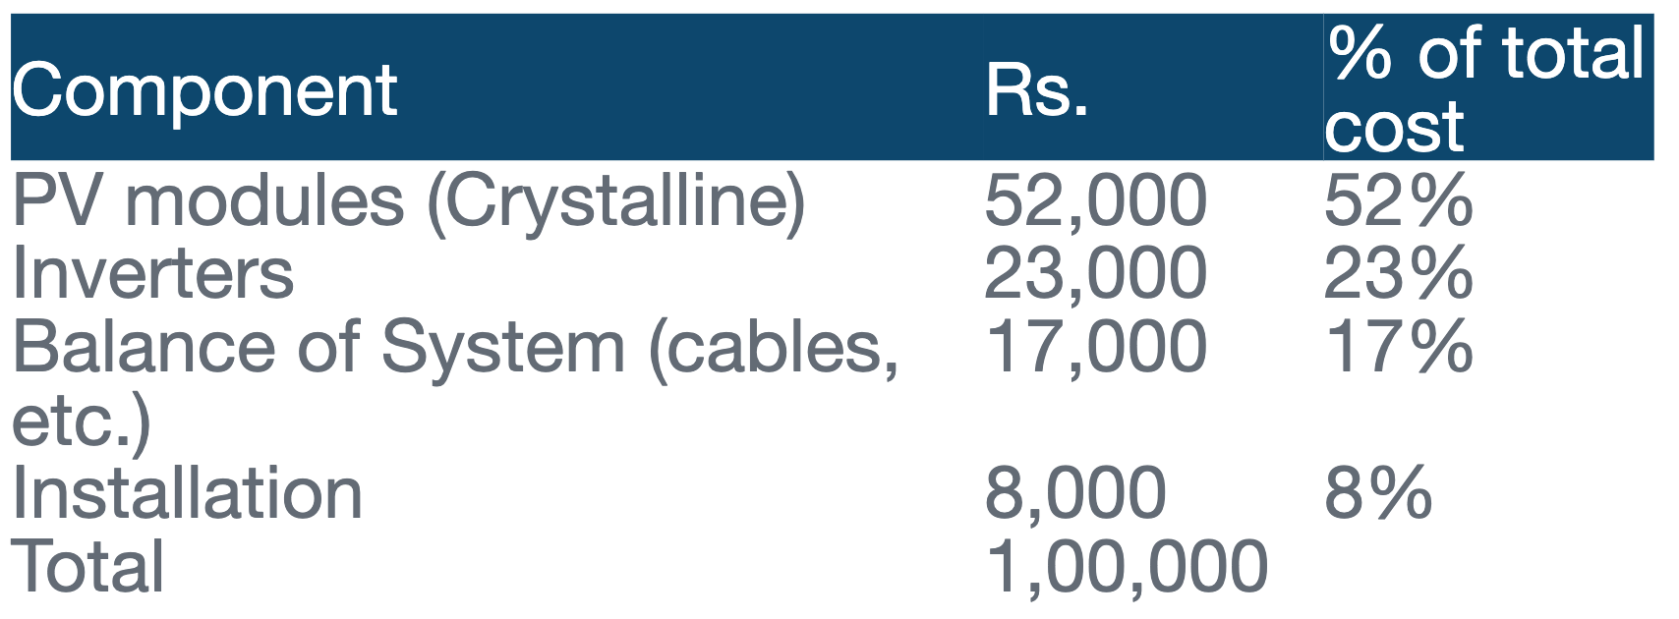

* The government provides subsidies and loan interest at as low as 5%. The cost analysis of setting up a rooftop PV system are as below –

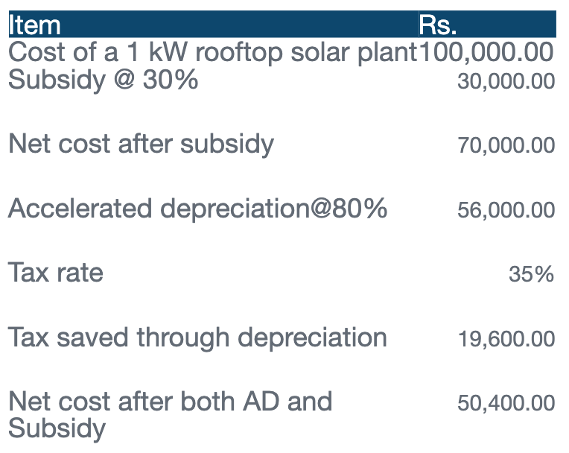

## Threat of New entry

* There is a threat of new entrants in both Solar equipment manufacturing as well as turnkey implementors.
* In India there is a huge gap between the available manufacturing capacity vs the actual requirement. To bridge this gap there is an impetus given by the government for setting up manufacturing units in India.
* There is a capacity availability of only 1.4 GW manufacturing indigenously, but the demand is huge. Demand outstrips the supply requirement. The gap is supply is fulfilled by imports from Chinese and other east Asian countries.
* Another challenge faced due to the gap in demand and supply has prompted smaller companies to come out with cheaper solar panels, batteries and inverters of a substandard quality. This reduces operational inefficiencies and increased maintenance costs in the longer run.
* Along with India, there is a huge demand from other ASEAN countries too.
* As with turnkey project implementors, there is a requirement for setting up 100 GW solar capacity by 2022. The per unit cost of electricity has dropped to as low as Rs. 2.44 per kWh as bid in one of the recent projects. The lower costs can be achieved by economies of scale and cost-efficient procurement and operations. The solar panels once installed serve for a lifetime.
* The target by 2022 would help reach 20% share of electricity requirements vis renewable energy.
* The exit barriers are huge due to the heavy investments made in plant setup and installing capacities. There are very low incentives to exit the industry due to the fact that it is in a growth stage and potential of exponential revenues in longer run.
* Solar equipment manufacturers can continually bring in latest technologies to improve the efficiency of solar panels. The varying efficiencies command superiors’ prices as noted earlier in the report.
* Turnkey project implementors are incentivized by long term flat price Power purchase agreements by DISCOMS guaranteeing a steady cashflow over years with a onetime investment.

## Competitive Rivalry

* Due to the low entry barriers, many PV manufacturers have flooded into the market driving up the innovation and reducing the costs.
* Engineering, Procurement and Construction (EPC) look for overall strength of the supplier apart from cost.
* This has resulted in running solar farms becoming cheaper than coal powered plants - Prices reduced from INR 17 in 2010 to 2.44 in 2019.
* The lifecycle of a solar industry can be summed up as below -

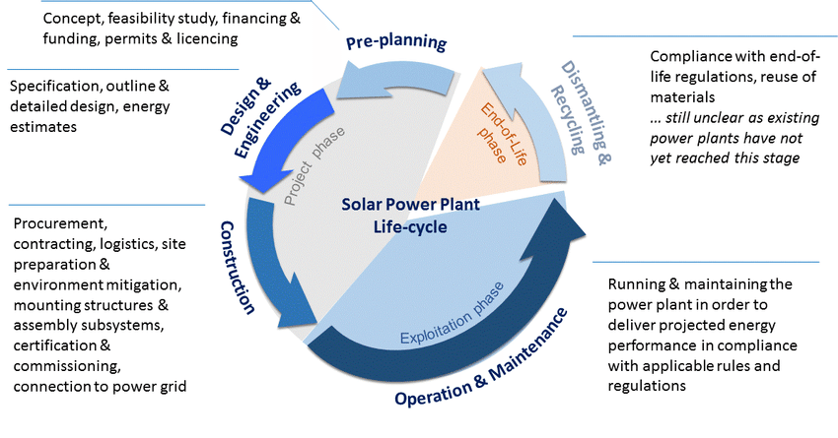

* There is a little quality difference between the offerings by the various suppliers and project implementors. The only playground they can compete on is the price offering of the final product. Lower prices can be achieved by lower costs and efficient operations. As seen in above diagram, cost efficiencies can be achieved during the construction and O&M phases.
* During the construction phase, low cost solar panels and other equipment’s and land availability at lower prices reduces the fixed costs.
* O&M can be made efficient by automation. Companies use data and AI driven technologies to predict potential maintenance activities. Technologies like Drones and remote cleaning and maintenance reduce the manual effort needed and hence the costs.
* Below table details the activities that can be automated to gain cost advantages -

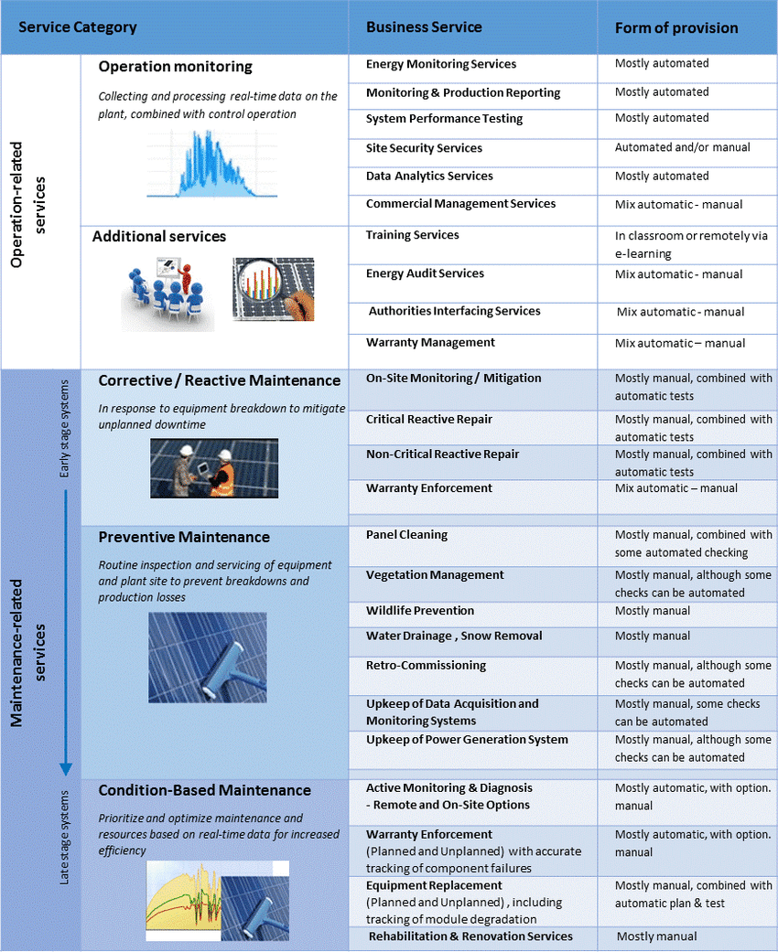

## The Adani Green Advantage

* Best positioned to tap Indian large renewable energy opportunity
* Clear visibility on 15 GW development sites
* Stable long-term cash flows with 25-year PPAs (60% with SECI / NTPC)
* Vertical integration into manufacturing - Continuous design improvement for plants
* Project execution and O&M capability
* Demonstrated financing capability - 80% operational portfolio refinanced on competitive terms
* Strong strategic relationship with supplier to provide user specific equipment at competitive costs
* Influence on suppliers by virtue of large portfolio across group companies
* Lifelong assets

## Growth Strategy - doing the right things the right way

* Growth and return focus - 46 operational and 18 project under construction.
* Optimal capital management -  improving efficiencies and undertaking cost optimisation initiatives to ensure sustained value creation
* Project execution & Operational excellence -  superior design, engineering, strategic procurement and project management abilities. Cluster-based operating model to ensure adequate support and governance at each site
* Stable cash flows - Power Purchase Agreements(PPA’s) of 25 years with central and state governments with ICRA rating AA+ and above.
* New technology and innovation - Dust Detection System (DDS) for module cleaning; Thermal imaging for hotspots, Data analytics and machine learning driven decision making

PESTEL Analysis of The Solar Industry

Political

Among the various renewable energy resources, solar energy potential is the highest in the country. In most parts of India, clear sunny weather is experienced 250 to 300 days a year. With the objective to establish India as a global leader in solar energy, by creating the policy conditions for its diffusion across the country as quickly as possible Government of India launched National Solar Mission.

1. The annual radiation varies from 1600 to 2200 kWh/m2, which is comparable with radiation received in the tropical and subtropical regions. The equivalent energy potential is about 6,000 million GWh of energy per year.
2. The National Action Plan on Climate Change also points out: “India is a tropical country, where sunshine is available for longer hours per day and in great intensity. Solar energy, therefore, has great potential as future energy source.
3. It also has the advantage of permitting the decentralized distribution of energy, thereby empowering people at the grassroots level”.
4. The National Tariff Policy was amended in January 2011 to prescribe solar-specific RPO be increased from a minimum of 0.25 per cent in 2012 to 3 per cent by 2022.
5. CERC and SERCs have issued various regulations including solar RPOs, REC framework, tariff, grid connectivity, forecasting etc. for promoting solar energy. Many States have come up with up their own Solar Policy.
6. In view of the ongoing efforts of Central and State Governments and various agencies for promoting solar energy, Ministry of New and Renewable Energy has undertaken an exercise to track and analyze the issues in fulfillment of Solar Power Purchase Obligation and implementation of Solar REC framework in India.
7. This would help various stakeholders to understand the challenges and opportunities in the development of solar power. It would also include monitoring of Solar RPO Compliance; analyzing key issues related to the regulatory framework for solar in various states of India.
8. In 2010 GOI announced the Jawaharlal Nehru National Solar Mission (JNNSM) and its target of developing 22,000 megawatts (MWs) of solar capacity by 2022. This target was revised by government in 2014 to 100 GW.
9. This was backed by presumption that the thrust of this will help meet its international commitments on carbon emissions. An estimated investment of 6 lakh crore would be needed to achieve this.
10. National Thermal Power Corporation’s (NTPC) power trading arm, the NTPC Vidyut Vyapar Nigam (NVVN), did conduct a reverse auction1 (a competitive bidding process) for the ﬁrst 150 MW of large-scale PV and 470 MW of CST
11. The central government’s massive RE targets require a commensurate increase in balancing capability at least in the RE-rich states. Balancing resources can be augmented by dedicated transmission corridors distributing RE across states, grid storage and additional flexible generation.
12. To make RE more attractive, the central government has worked out ways of subsidising it at the cost of public sector companies in the power or fuel sector. Interstate transmission charges for solar electricity have been waived at the cost of the Power Grid Corporation of India.
13. To make sure that states comply with the Renewable Purchase Obligation targets, such compliance has been made part of the conditions associated with the “Ujwal Discom Assurance Yojana” (UDAY) that provides relief to indebted state DISCOMS(Distribution Companies)
14. A slower adoption of solar will be beneficial as in the long term, as the technology progresses, the cost of solar power production, transmission and storage will get cheaper.

Economical

Policy and regulatory framework from the government is to create a policy and regulatory environment which provides a predictable incentive structure that enables rapid and large-scale capital investment in solar energy applications and encourages technical innovation and lowering of costs.

1. Although there is a need to establish a sector-specific legal and regulatory framework for the development of solar power, in the shorter time frame, it would be necessary to embed the activities of the Mission within the existing Page 8 of 15 framework of the Electricity Act 2003.
2. The National Tariff Policy 2006 mandates the State Electricity Regulatory Commissions (SERC) to fix a minimum percentage of energy purchase from renewable sources of energy taking into account availability of such resources in the region and its impact on retail tariff.
3. **States Government initiatives to boost the solar power industry :** National Tariff Policy, 2006 would be modified to mandate that the State electricity regulators fix a percentage for purchase of solar power. The solar power purchase obligation for States may start with 0.25% in the phase I and to go up to 3% by 2022. This could be complemented with a solar specific Renewable Energy Certificate (REC) mechanism to allow utilities and solar power generation companies to buy and sell certificates to meet their solar power purchase obligations.
4. **Central Government initiatives to boost the solar power industry:** The Central Electricity Regulatory Commission has recently issued guidelines for fixing feed-in-tariff for purchase of Solar power taking into account current cost and technology trends. These will be revised on an annual basis.
5. Many investors are willing to set up solar based power plants. However, sale of power by the IPPs may be an issue due to the high cost of power and realization of tariff for the same from the distribution companies.
6. NTPC has a wholly owned subsidiary company engaged in the business of trading of Power – NTPC Vidyut Vyapar Nigam Ltd. (NVVN). NVVN as nodal agency by the Ministry of Power (MoP) for entering into a Power Purchase Agreement (PPA) with Solar Power Developers to purchase solar power fed to 33 KV and above grid, in accordance with the tariff and PPA duration as fixed by the Central Electricity Regulatory Commission.
7. NVVN supplies bundled power to State utilities at the rates determined as per CERC regulations, those State utilities will be entitled to use the solar part of the bundled power for meeting their Renewable Purchase Obligations (RPO) under the Electricity Act, 2003.
8. The CERC may issue appropriate guidelines in this regard. At the end of the first phase, well-performing utilities with proven financial credentials and demonstrated willingness to absorb solar power shall be included in the Scheme, in case it is decided to extend it into Phase II.
9. The requirement of phased indigenization would be specified while seeking development of solar power projects under this scheme. The size of each project would to determined so as to make phased indigenization feasible.
10. The tariff and tax regime for key components and segments would be suitably fine-tuned so as to promote the process of indigenization.
11. The Mission will encourage rooftop solar PV and other small solar power plants, connected to LT/11 KV grid, to replace conventional power and diesel-based generators. It is envisaged that distribution utility will pay the tariff determined by the State Electricity Regulatory Commission for the metered electricity generated from such applications (whether consumed by the grid connected owner of the rooftop/ground mounted installation or fed into the grid).
12. Under the Solar Mission, a normative Generation Based Incentive will be payable to the utility and would be derived as the difference between the solar tariff determined by the Central Electricity Regulatory Commission for the concerned solar generation technology less an assumed base price of Rs. 5.50/kWh with 3% annual escalation. Funds will be disbursed through Indian Renewable Energy Development Agency (IREDA), a PSU under MNRE.
13. The distribution utilities will be entitled to account such electricity generated and consumed within their license areas for fulfillment of RPOs. The metering and billing arrangements between the utility and the rooftop PV operator, will be as per guidelines/regulations of the appropriate commission State Governments would also be encouraged to promote and establish solar generation Parks with dedicated infrastructure for setting up utility scale plants to ensure ease of capacity creation.

Social

India is endowed with vast solar energy potential. About 5,000 trillion kWh per year energy is incident over India's land area with most parts receiving 4-7 kWh per sq. m per day.

1. Technology routes for conversion of solar radiation into heat and electricity, namely, solar thermal and solar photovoltaic, can effectively be harnessed providing huge scalability for solar in India.
2. Solar also provides the ability to generate power on a distributed basis and enables rapid capacity addition with short lead times.
3. Off-grid decentralized and low-temperature applications will be advantageous from a rural electrification perspective and meeting other energy needs for power and heating and cooling in both rural and urban areas.
4. From an energy security perspective, solar is the most secure of all sources, since it is abundantly available. Theoretically, a small fraction of the total incident solar energy (if captured effectively) can meet the entire country's power requirements.
5. It is also clear that given the large proportion of poor and energy un-served population in the country, every effort needs to be made to exploit the relatively abundant sources of energy available to the country.
6. While, today, domestic coal based power generation is the cheapest electricity source, future scenarios suggest that this could well change.
7. India already has some 20,000 solar irrigation pumps (SIPs) in fields; and farmers everywhere seem happy with their performance and potential
8. Accelerated depreciation of 80% is provided under the Income tax act for rooftop social PV systems. This provides a significant saving for the solar plant developer.
9. MNRE (Ministry of New and Renewable Energy) provides financial assistance through capital or interest subsidies. Individuals, non-commercial and commercial applications can get loans at as low as 5% pa and subsidies up to Rs.51/watt for system with a battery backup.
10. REC’s(Renewable Energy Certificates) can be traded on power exchange and sold to organizations that need to fulfil Renewable Purchase Obligations for rooftop plants of 250kW or higher capacity.

Technological

Tons and tons of technological innovations are taking place which not only makes it favorable for the solar industries but also makes sure that the future of using solar energy is getting brighter day by day.

1. Mini Solar Panels are available in the market which can power the small equipment; not only this innovation would lead to a shift of people’s mentality towards using solar energy only for the big corporate or at domestic level to using it for smaller equipment like torch, mobile charger etc.
2. Monocrystalline panels are premium solar products which are very efficient – such products in the market not only increase the productivity of the panels but also put solar energy stand in shoulder to shoulder with other forms of energy.

Not only they are efficient, but also, they are having a good longevity which makes them a good counter for other forms of energy.

1. Polycrystalline panels are cheaper, but less efficient than the one stated above.
2. A favorable estimate says that the solar power can provide for 20% of the electricity for an office use, which not only would help the offices to save more energy and use cleaner form of energy.
3. Many of the universities are currently studying the situation of solar industry: one of the universities which are contributing in building the world a cleaner place is University of Toledo, which is producing high efficiency and low-cost solar cells which can be used for domestic purposes as well.
4. The use of solar energy required a very low maintenance cost.
5. Despite the technological advancement, the use of solar energy is still a major concern.
6. Majority of the time, the solar installments require too much of a space. Despite there are solar equipment that are smaller but there is still time left to reach the majority of the general masses.

Environmental

1. Solar energy is already considered as a form of energy which neither produces any sort of pollution – be it noise, or air.
2. It is one of the forms of energy that is renewable in nature and can be used infinitely.
3. Weather is one of the biggest enemies of solar industry which is a big hindrance to all the players in the industry; not only would this stop their equipment to be redundant during monsoon as the climatic condition is varies pretty much.
4. Installation of solar system has always given rise to the emission of greenhouse gases. It might not be polluting the environment in ways that we have seen but greenhouse has another way to damage the environment.
5. One of the major components of Solar Industry is the use of photovoltaic cell – the making of this cell involves different kind of toxic material and hazardous products which impacts the environment in a very drastic manner.
6. It's the sunlight that heats the solar panel and considering the fact that ultraviolet rays contribute to just 7% of it, there isn't much of an impact from UV rays in heating the panels.
7. At many places people are getting calls about UV solar panels which is nothing but a con job. They aren't effective but a marketing gimmick. Neither they are efficient nor harmful to solar panels.

Legal

1. The auction of Solar auction has been at halt in Tamil Nadu. Instead, it will buy clean power from the Solar Energy Corporation of India (SECI) to fulfill Renewable Purchase. As Tamil Nadu is one of the leading states in the country to use a renewable source of energy, and such kind of halt would impact the solar industry.
2. The government is mulling to increase the subsidy on rooftop solar panels from the present 30%, sources in the New and Renewable Energy Development Corporation of Andhra Pradesh. More than 60% of the commercial and service organizations have installed on-grid rooftop solar power system and are utilizing the power for water heating and cooking
3. The government is also planning to provide easy loan schemes to people who are opting for the solar energy.
4. Delhi Dialogue Commission presented the draft solar policy which proposes to develop Delhi as the solar city and producing 1000 MW in a span of 5 years which would get completed in 5 years.
5. The ministry of new and renewable energy has recently approved a proposed master plan to develop 50 solar cities, including three in NCR. Of the proposed 60 solar cities, sanctions have been issued for 50, which include New Delhi, Agra, Chandigarh, Gurgaon, Faridabad, Amritsar, New Town (Kolkata), Howrah, Madhyamgram, Kochi and Bhopal.
6. Govt support to promote the use of solar energy has increased drastically. Not only are they wanting it to get used but also providing various kinds of subsidies, and other offers to install the same.
7. Cheap loans and maximum use of solar energy limits have increased.
8. The government of India has announced national wind-solar hybrid policy to promote new projects as well as hybridization of existing ones. All fiscal and financial incentives available to wind and solar power are made available to the hybrid projects.

# Financial Performance of Solar Industry

Based on our study of the 10 companies of the solar industry, we have performed financial analysis of the two different segments of the industry, namely “solar equipment manufacturers” and “turnkey Project developers”.

## Capital Structure Analysis

The asset structure of the industry is heavier towards the fixed, non-current assets with 53% of the investment in fixed assets w.r.t total assets. Also, Turnkey project developers rely heavily on fixed assets with 64% weightage in comparison to solar equipment manufacturers with 42%.

The aggregate debt-equity ratio for industry is reeling at -0.38 signifying the firms in the industry are ill managed and do not possess enough equity to cover their debts in liquidation scenario with IndoSolar being the prime example of such ill-management.

The solar equipment manufacturers have a very good debt – equity structure with equity covering almost all of the debt whereas the turnkey project development firms have a negative ratio at -1.79 signifying losses suffered by these firms.

## Profitability of the Industry

The net profit margin for Solar Industry stands at a low of -18% indicating that it is a high loss-making industry. The “Return on Invested Capital” (ROIC) for the industry is marginal at 0.2% while “Return on Capital employed” (ROCE) stands at 21%.

Firms associated with manufacturing solar equipment have a positive NPM, ROIC and ROCE of 3%, 3% and 28% respectively. Companies implementing turnkey projects have a negative NPM and ROIC of -38% and 0% respectively. While they have very low ROCE of 14% in comparison to solar equipment manufacturers. Since the industry requires heavy investments for implementing solar projects, companies implementing these have shown a laggard performance over years.

**As per the ROCE & ROIC ratios, the companies that gave highest return on capital are: - Bright Solar, Genus Power, UJAAS, Surana Solar & WAA Solar.**

Key Performance Indicators Analysis

The ROE average for Solar Industry stands at a decent 25%. Barring for a few companies, this has been stable for the industry. Turnkey project developers give better returns of 34% compared to solar equipment manufacturers giving 21%.

Most of the companies have been able to generate positive Operating margin, indicating they have been able to effectively generate profit from their sales with a ratio of 6%. However, solar equipment manufacturers have better operating profit of 9% than turnkey project developers with 3%.

Notably, Indo Solar has not been able to gain operational efficiencies in their business causing them to file for insolvency.

The interest burden and tax burden for the industry reduces the profits by 19 and 20 basis points respectively. Due to heavy subsidies provided by the government, the tax management of the companies is efficient leading to PAT ≈ PBT.

## Asset Turnover

The average asset turnover for companies in Solar industry hovers around 0.68 signifying efficient usage of assets. However, the Solar industry has been generating good value for investment for the solar equipment manufacturers which have efficient operations.

Firms with major revenues coming from Solar equipment sale like Bright Solar, Surana Solar, Solex have a good Asset to Sales ratio ranging between 0.7 to 1.4. While, firms with focus on turnkey projects business model like Ujaas, Adani Green, WAA Solar, etc. have not been able to utilize their assets efficiently in pursuit of generating sales and have asset to sales ratio ranging between 0.5.

## Valuation Ratios

The average PE ratio for the industry is 16.87, indicating the industry is yet undervalued and investors have a good opportunity to earn through a long-term investment. The PE ratio has been steadily increasing from 6.61 to 26.99 in recent financial years. This indicates growing confidence of the investors towards the industry.

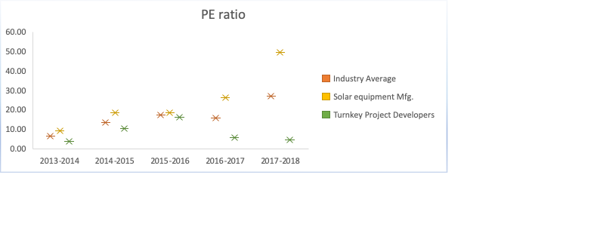

The firms give an average earnings per share of 3.43 to its investors and a dividend yield of 1%. Solar equipment manufacturing firms earns 4.17 per share as against the solar turnkey project development firms with 2.69.

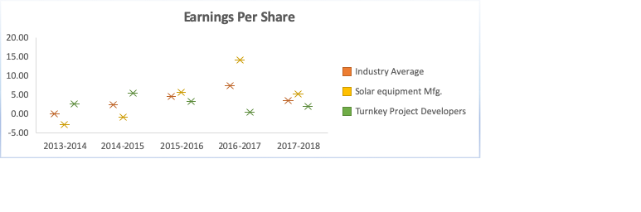

## EBITDA Multiple Analysis

The average EBITDA multiple for the solar industry stands at a healthy value of 6.54 signifying that the industry is able to generate value for the firms that operate efficiently.

Also, Indosolar has an EBITDA multiple of 4.82 which is below industry average, but the firm can still be continued after removing the major obstacles preventing the firm from reaching its true potential. WAA Solar needs to start working towards bringing better operational efficiency.

## Liquidity Analysis

The industry average for Current Ratio is 1.55 indicating the short-term liabilities are well covered by the current assets. This indicates that the financial position of the companies is strong. The cash ratio stands barely at 0.32, indicating cash and other marketable securities are not able to completely cover for the current liabilities.

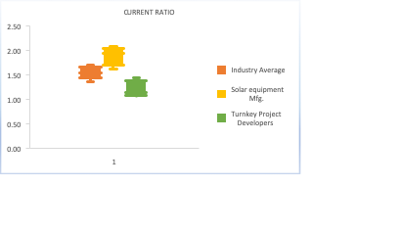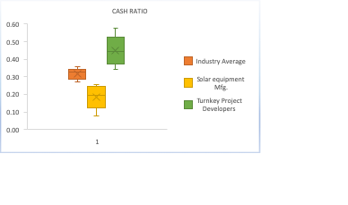

## Working Capital Analysis -

### Operating Cycle & Cash Cycle:

The solar industry has an average operating cycle ranging between 120 - 270 days. While companies dealing in large-scale power project, turn-key project or project consulting have a longer operating cycle of 100 days to more than 1 year approx. Waa Solar is an exception to this norm with efficient operating cycle. The industry aggregate for operating cycle is 176 days which requires the solar industry companies to have huge working capital.

The industry aggregate for Cash cycle is 74 days or 3.5 months approx. which impacts the profitability as well as the liquidity of the companies since the cash is tied up due to non-optimal working capital & cash cycle management.

### Dividend Payout & Ploughback Ratio:

The industry aggregates for dividend payout and ploughback ratio are -0.07 and 1.07 respectively. This indicates that the companies have been in very low profits or losses and is forced to invest all the profits back into the business. As a result, the solar industry companies have declared no or negligible dividend payout.

### Sustainable Growth Rate:

The sustainable growth rate of solar industry is 15% indicating that the industry needs to rely on external financing options for future growth.

## CAGR Comparison Analysis of key financial metrics -

### Revenue & COGS:

The companies in solar industry have various revenue streams with products or services ranging from solar power manufacturer, turnkey solar project developers to providing wide array of solar products like solar PV modules, solar water pumps, solar rooftop panels, solar lighting, etx.

We can observe that Websol, Surana Solar & Ujaas have recorded a decline in their revenue over the course of recent years. Further looking at comparison of CAGR of COGS and Revenue from operations for all companies across solar industry suggests that the revenue is tied to usage of raw material in this industry.

But it is also interesting to observe that IndoSolar which has recorded growth in revenue has been unsuccessful in containing the COGS & is undergoing Corporate insolvency process at the time of writing this report (FY: - 2019-20).

### Depreciation Rate:

In order to promote solar power usage, the Government of India has declared accelerated depreciation rate of assets related to solar power up to a maximum of 40% annually in order to claim tax benefits. Most of the companies have taken advantage of this benefit with Adani Green, Solex recording maximum CAGR in their depreciation rates.

1. Profit & Equity:Only few companies have been able to record growth in profits with most companies recording a loss in profits in recent years. This is evident from the fact that most companies have recorded negative CAGR for PBT. It is also worth noting that the companies with positive growth in PBT have seen considerable increase in their equity share capital.

### Assets & Liabilities:

The industry trend suggests that most solar companies have reduced their investments in the fixed assets as well as their long-term loans.

Indosolar, which is undergoing insolvency process, has recorded a degrowth in “short-term loans & advances” and a growth in their “trade payables” indicating the risky financial uncertainties faced by the company.

## Revenue & Cost drivers for the future growth of solar industry -

Based on the financial study of the solar industry, we will perform a detailed financial analysis of Swelect from Solar Equipment manufacturer and Adani Green representing TurnKey project developers in order to determine their future growth prospects in both the segments and understand their revenue breakup and cost structure.

### Future Revenue Growth of Swelect and Adani Green

Here, we analyze the two company’s sustainable growth rate, forecasting their sales revenue and analyze the soundness of their business by comparing their revenue and cost structure. Also, to forecast their future growth and issues, if any that management should concerns themselves with.

### Sustainable Growth Rate (SGR):

**Adani Green** has a negative SGR of -1.62 which shows the company is not profitable and making losses. Company does not have adequate profits to reinvest and needs to fund its growth externally through lenders and investors. While **Swelect** can attain a sustainable growth of 0.6 % using its current resources and does not require any external financing through debt or equity.

### Forecasted Sales Revenue:

SWELECT: The solar industry is reliant on imported solar panels from neighboring countries like China, Thailand, etc. Future sales revenue is adversely impacted by increase in SPV module prices due to government-imposed Safeguard duty of 25% and rupee depreciation. But, the extension of safeguard duty is still under review. Management’s outlook for future sales revenue is optimistic due to various provisions announced by the Finance Minister for the renewable energy industry including expansion of PM KUSUM Scheme, use of barren land for solar power, increased solar energy generation via Indian Railways tracks, reduction in corporate tax rate for new energy companies, abolishing dividend distribution tax, addressed concerns of start-ups, proposed prepaid smart meters to strengthen Discoms among others. Also, the firm went major restructuring in recent years due to one of the subsidiaries filed for closure in FY 2019. The firm has also added another business line in FY 2018. Bottom-Up Estimate each revenue item based on our study of the company and the industry conditions:

1. Company has installed additional power plants, which is expected to increase the revenue w.r.t "Sale of Power" along the long-term growth trajectory.
2. There is delay in deployment of any new solar power plant & roof-top projects due to industry conditions. We expect the "Sales of Products" revenue to marginally increase by 1%.
3. "Revenue from Service Concession" is no longer reported due to new accounting rule "Ind AS 115".
4. "Other Operating Revenue is expected to grow. And determined using CAGR approach.

ADANI GREEN: Forecasted sales revenue is expected to show minimal growth based on our study of the company and the industry conditions. Management's outlook for sales revenue for FY2020 and upcoming recent financial years is adversely impacted by non-availability of capital from PSU banks for private investment. This is coupled with industry wide deacceleration due to safeguard duty. Bottom-Up Estimate each revenussse item based on our study of the company and the industry conditions: -

1. Adani Green has many new large-scale power plant projects in Tamil Nadu which is its main source of revenue. The "Revenue from Power Supply" is expected to follow a long-term growth trajectory and determined using CAGR for last 3 years.
2. "Revenue from EPC" is no longer reported due to new accounting rule "Ind AS 115".
3. "Other Operating Revenue" is expected to grow marginally determined using CAGR approach.
4. "Revenue from Traded Goods" is impacted due to Safeguard duty, and is expected to marginally increase by 1% due to reduction in safeguard duty from this financial year.

### Revenue Drivers: -

SWELECT: Swelect has business processes across the value chain of solar industry. The firm has introduced new business vertical for providing solar consulting services. Swelect has both installed power plants as well as solar equipment manufacturer in order to become an end-to-end solar energy solutions provider. The main driver for Swelect’s revenue is the revenue from the “sales of products”, that is solar equipment manufacturers. The “Sales of Power” is another key contributor with the new services vertical still needing sometime to give sufficient sales revenue.

ADANI GREEN: Adani Green is one of the largest renewable companies in India, with a current project portfolio of 5,290 MW. The firm develops, builds, owns, operates and maintains utility-scale grid-connected solar and wind farm projects. The electricity generated is supplied to central and state government entities and government-backed corporations. Revenue from traded goods contains revenue from EPC (Engineering, Procurement and Construction) projects due to new accounting rules.

Key revenue drivers for Adani green as sales from traded growths and sales from power supply. Also, revenue from traded growth has increased exponentially.

### Projected Revenue Vs Cost Structure:

**SWELECT:** 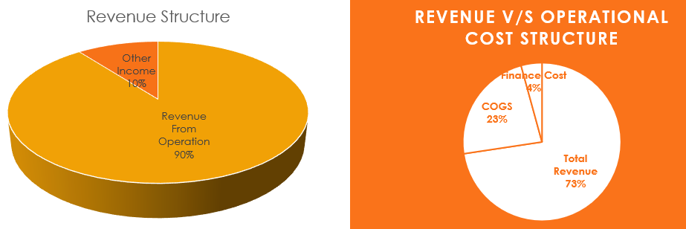

**ADANI GREEN:**

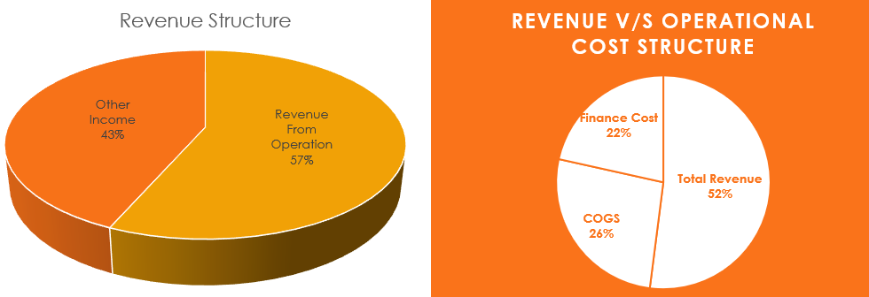

Swelect’s forecasted sales revenue is majorly driven by their operational revenue while for Adani Green, the sales revenue is partially driven by operational revenue. And “Other Income” forms a substantial percentage of 43% which the management of Adani Green should look into.

Swelect’s sales revenue is far more than their finance Cost and COGS combined, and the company has been profitable. Although, COGs are expected to be high in solar industry, but the company needs to look at improving its COGS. While Adani Green’s Finance Cost and COGS eat up major part of Total Sales Revenue, which is the management is trying to put a check on.

### Forecasted Du Pont Analysis:

Swelect gives a good return-on-equity of approximately 1%. While Adani Green has been improving its return-on-equity by reducing its finance cost but it is hovering at negative return-on-equity of -1%.

**It is also worth noticing that while for Swelect, the 24% of the sales are driven by assets while for Adani Green, sales are only 6% of assets.**

SWELECT: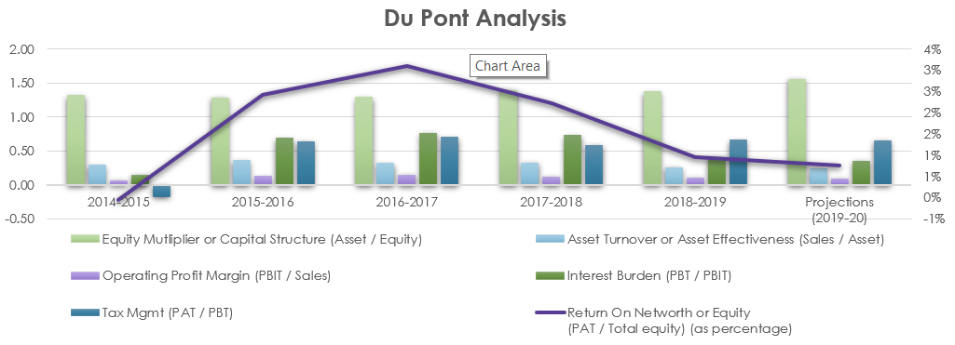

ADANI GREEN:

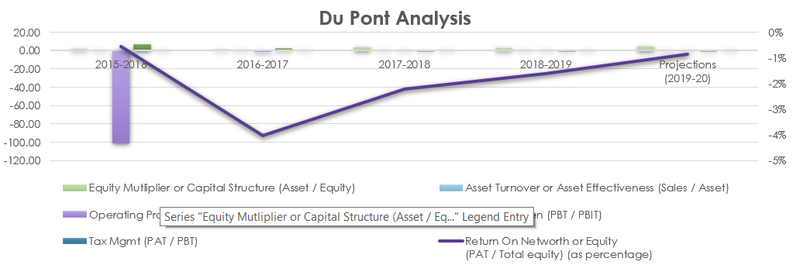

Setting up 5MWp/10 MWp Solar PV module Production unit

* Upcoming demand of Panels in India = 22.30 millions of 250Wp SPV Panels (19%)
* Upcoming demand in China = 24.04 millions of 250Wp SPV Panels (20%)
* Upcoming demand in United States = 56.72 millions of 250Wp SPV Panels (48%)
* Total demand in those 7 countries = 118.17 millions of 250Wp SPV Panels (100%)

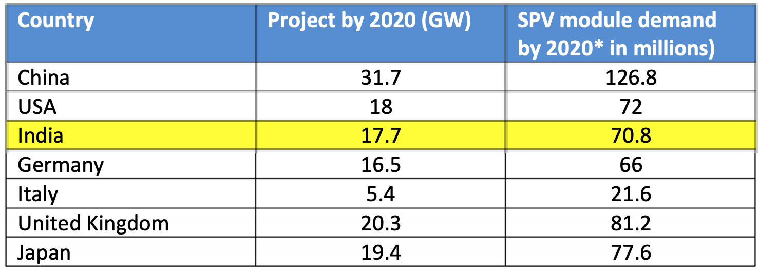

* Large-scale projects are underway or planned to be introduced very early in India
* Residential / home installations have risen by almost 40% by 2013
* Large-scale opportunities to export solar photovoltaic modules to the global market
* Countries that are now in the first phase of deployment of solar energy, favor Indian companies more
* Small-scale projects such as solar irrigation, rooftop solutions, Exporting solar photovoltaic panels to the global market recently announced some great policies and tax relief, which is a very good indication of high profit.
* Indian Govt. recently announced some great policies and relaxation in tax duties which is a very good indication for high profit may be attended by exporting solar PV Panels to global market

For 5 MWp year PV module production capacity:

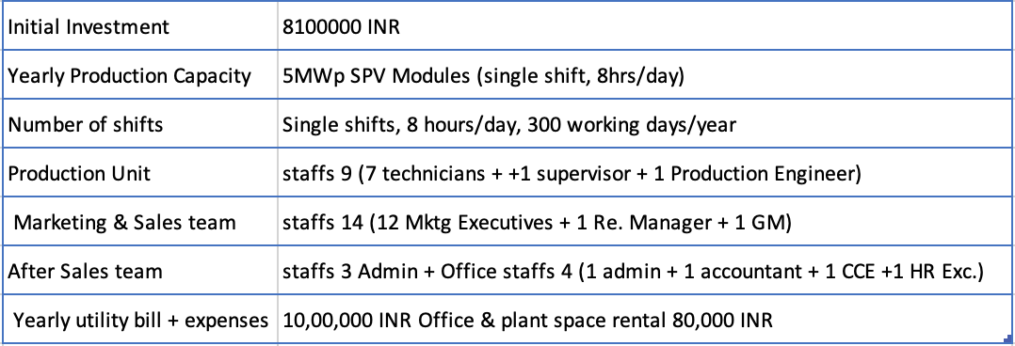

The payback happens in 3.04 years. Since the cost implications after initial investments are low, the ROI calculated over 7 years is 36.8%

Material Requirement

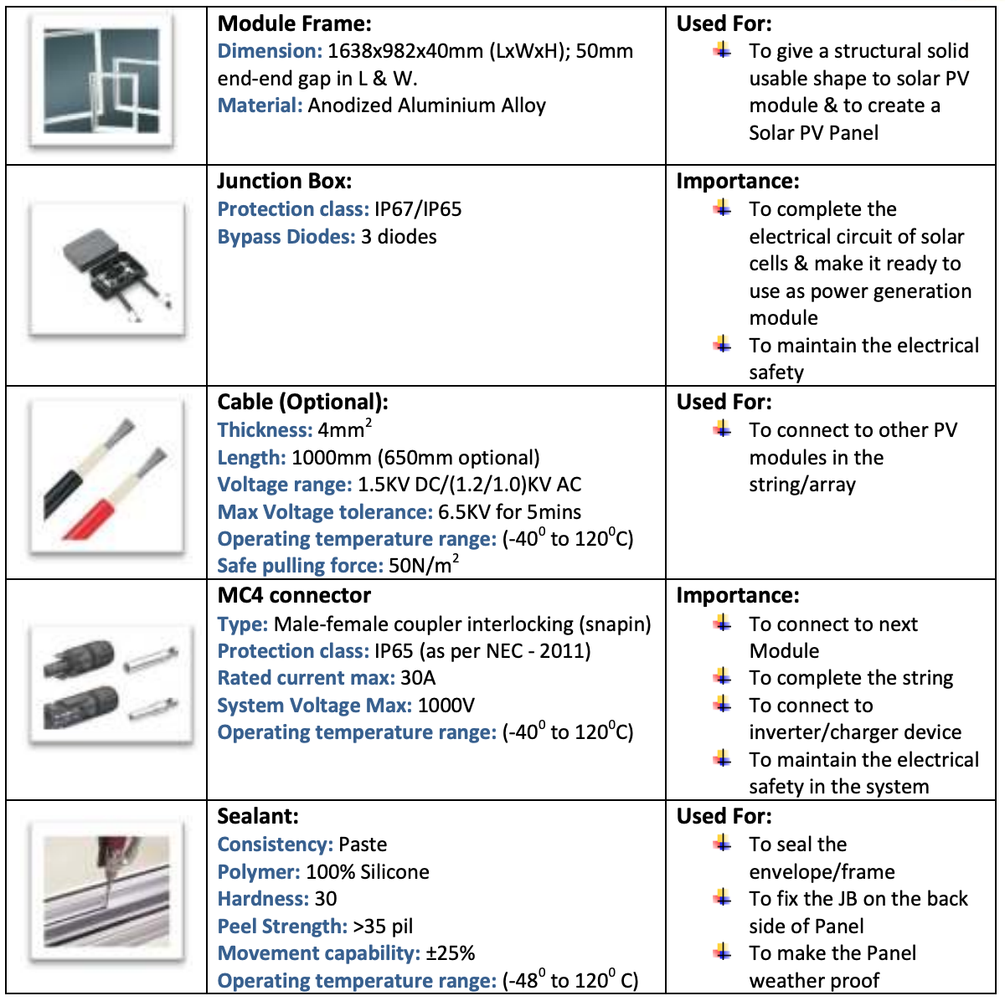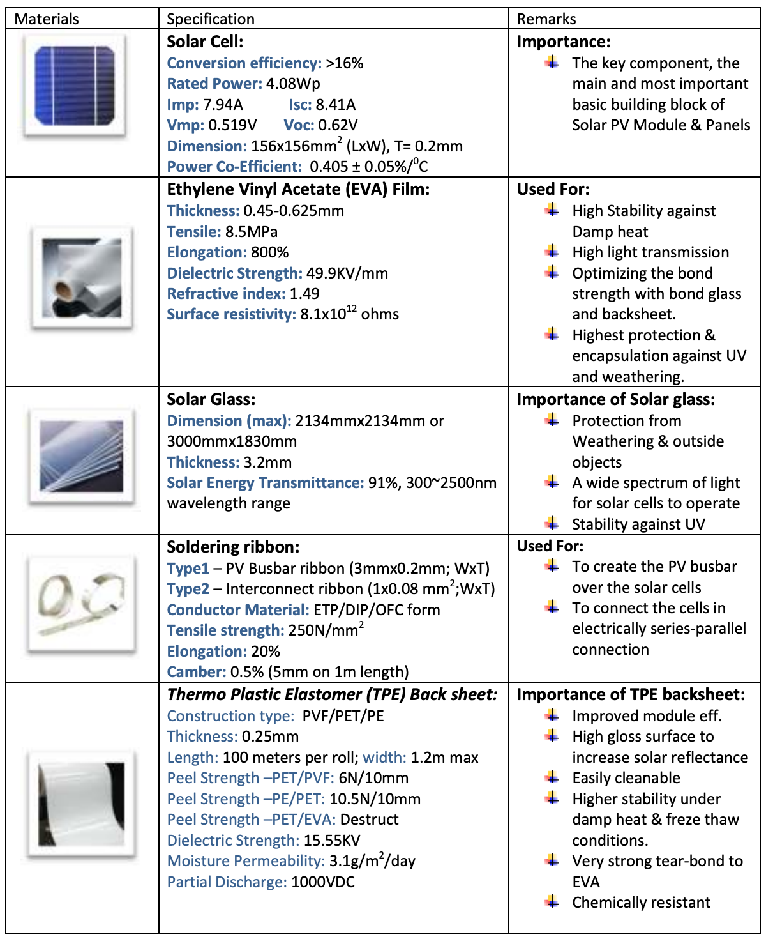

# Supply-Chain Management

Swelect Energy has been focused on playing an integral part in the customer value chain. Adani Green are more reliant on large scale solar power plants, but they have also invested in solar PV modules to a limited extent. The interdisciplinary group of solar industry experts blends global resources with business finance, procurement and logistics experience to create valuable managed business solutions for customers in over 50 countries in the Solar Group.

Swelect Energy Supply chain solutions are a trusted source for leading manufacturers of photovoltaics, solar project designers, EPCs, contractors and installers worldwide. Swelect Energy provides the global warehousing and trade finance capabilities required to create differentiated value while effectively managing long-term material supply agreements.

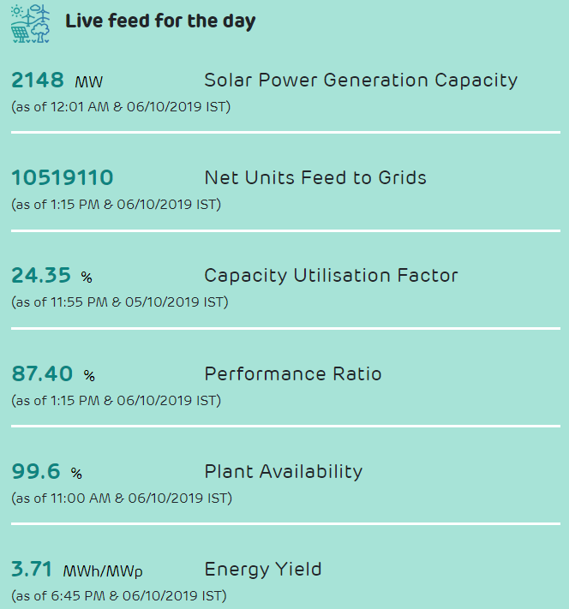

Adani Green has deployed advanced technology and uses data analytics to achieve higher operational efficiency from its solar parks. The Company is using Remote Operations Nerve Center (RONC) which uses machine learning algorithms and drones for monitoring the progress of its projects. They also use RFID and GPS technologies to automatically track assets, manage inventory and maintenance of their solar parks.

Swelect Energy's supply chain begins from suppliers to end customers. Any constraints in the supply chain from suppliers to end users via manufacturing involving amongst other vendors and the dealers can have a severe impact on the performance of the Company. The Company is mainly in the Domestic Market for the supply of Solar Photovoltaic Modules. The Company also entered into export market which is risky since sudden fall in demand globally means underutilization of capacity and the Solar Photovoltaic cells is in shortage internationally due to sudden surge in demand, which may affect the margins of the Company. The operations of the Company depend on the continued and uninterrupted supply of power and raw materials such as glass, back sheet, cells, aluminum etc. the supply and cost of which can be subjected to significant variation due to factors beyond the control of the Company. The Company is dependent on various domestic/foreign suppliers for the supply of raw materials. If the Company is not able to obtain adequate supplies of raw materials in a timely manner or on acceptable commercial terms, or if there are significant increases in the cost of these supplies, the business and future results of operations of the Company may be materially and adversely impacted.

Logistic Capabilities

* Warehouses in Canada, U.S., Czech Republic, Netherlands, India, China, South Korea
* Partner warehousing facilities in over 20 other countries
* In-house freight specialists in multiple countries
* Company-operated rail fleet of over 150 cars
* International ocean vessel chartering experience
* Short- and long-haul trucking partners worldwide

PV Market in India:

The basic raw material – silicon wafers – does not have a manufacturing base in India. Therefore, the industry relies on international markets to supply the raw material. In the past, the silicon market was highly fluctuating, resulting in a demand-supply equation imbalance, fluctuating prices and availability of raw material. Today, the potential for silicon production is much higher than demand, and prices are significantly lower than the scenario a year ago. Some of the solar photovoltaic companies have in the past entered into price agreements with suppliers of silicon wafer to ensure availability. China is the world's largest producer of solar cells over the past five years. Compared to India's 400 MW, the country currently has around 2,500 MW of solar PV production capacity. Besides that, Taiwan also emerges as a major threat to the Indian industry, with an annual capacity of 800 MW. The reduction of prices is another major challenge for the industry, as this would have had a significant impact on future market growth. Solar PV applications in India have followed a different trend from global practices. While globally, there has been a higher focus on grid-connected applications, the Indian PV market has predominantly focused on off-grid applications.

## Photovoltaic Supply Chain

The Photovoltaics Supply chain tracks all distinct processes required to build a PV system. Next, raw materials must be made, purified in Ingot, cut and coat into wafers, which is the polysilicon. Subsequently, the cells formed in this way are assembled into modules and, when combined with electrical components, a complete device is built.

Now the Supply of Polysilicon Wafers is a Critical Driver of Cost & Quality in the Photovoltaic Industry and Maintaining the quality of this polysilicon is very critical. In general, Polysilicon Ingot & Wafer Production is Generally Located Near Cell Plants to Ensure Uninterrupted Supply. Crystal growing and casting plants are best suited where there is an abundant source of reliable, cheap energy to power the high-temperature operations. In 2008, the US was the largest producer of polysilicon. But the market is changing quickly now. Newcomers, especially from China, have moved into this market which has been reported in 2017. Again, Solar cell plants are complex and large. Because this is a highly capital-intensive part of the manufacturing chain, most manufacturers seek to centralize this activity at a few locations. Thus, solar cell production will typically service international markets from a single facility.

At a fully operational 50 MW Plant, around 300 jobs might be created, including operational, warehousing, fabrication and overhead administration. But, the actual number will be dependent on the chosen technology and degree of automation.



## Value Chain Analysis:

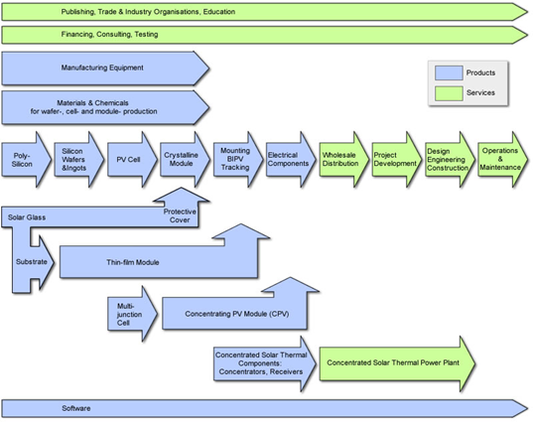

The value chain starts with the production process only covers the upstream portion of the value chain, while most of the operations take place in the downstream part. It involves many phases like project planning, implementation, etc. The project planning phase is very important. It involves area planning, system preparation, operational model, applying for approvals for the use of land, and considering different financial options. When this has been completed, the installation stage, in which the actual construction process takes place, will be checked and the system installed. The final part of the downstream value chain is the process of use, requiring a complex technical specification. In terms of project planning, the use phase involves consideration of political and country risks.

First, a whole series of products are required for the construction of a solar PV system:

* Suppliers of the manufacturing equipment
* Suppliers of the raw materials for wafer-, cells- and module production
* Producers of crystalline silicon
* Producers of silicon wafers and ingots
* Producers of PV cells and modules
* Producers of electrical components
* Software suppliers for monitoring system and operation of PV solar plants

There are services mentioned here - financial, legal, consulting and testing services that go through the entire value chain, as these services may be needed at each level. Different projects such as staff education and training, publishing and Marketing efforts to promote solar energy, etc. can also be included. There are also several essential resources when it comes to the actual phases of the value chain:

* Wholesale distribution
* Project planning and development
* Design, engineering, and construction
* Operations and Maintenance services

Entire operation can be carried out in an optimal market environment by various organizations entering into contractual relationships with each other. However, Swelect Solar tend to optimize their cost structures by reducing transaction costs. There are several ways to do: a cluster can be formed, concentrate similar and interdependent operations in one area (e.g. manufacture of silicone, wafer and modules), organize the process horizontally, incorporate various stages of manufacturing or downstream activities into the company structure. etc.

## Operational Cost Structure:

India is the third-largest solar market, and solar has overtaken wind and all other technologies to become a leading power source. Swelect Energy with proven track record and a deep market understanding was successful in taping key revenue opportunities. Below is the cost structure from their operations point of view:

|  |  |  |
| --- | --- | --- |
| **SL No** | **PARTICULARS** | **Amount (INR Lakhs)** |
| 1 | Cost of raw materials and components consumed | 13,650.38 |
| 2 | Purchase of traded goods | 356.34 |
| 3 | Increase in inventories of work-in-progress, traded goods and finished goods | (1,400.55) |
| 4 | Excise | 8.50 |
| Total Cost | | 14, 015.22 |

Human Resource Management Dimension

HRM is considered a logical approach to the management of an organization’s most valued assets. The objective of HRM is to help an organization, maintaining employees to congregate strategic goals and also to manage them effectively. The three key HRM activities in solar industries are

* Recruitment of the best employees
* Development of Leadership
* Development of Management

The main objective of Solar Industries is to identify and describe the broad range of policies, technical, financial, regulatory, and other market related factors that affect of renewable energy technologies. Firstly, recruiting the right employees with the right competencies at the right time had to fit in the solar industries as there is skills shortage at all levels in the organization.

To work in a solar sector, the desired technical skillsets include knowledge of CAD, PVSyst and experience in designing PV systems at 11/22/33/66 kV power levels. They should also have a knowledge of Operations and maintenance of HT equipment and Transmission lines. For a managerial role, one should be adept with general knowledge of solar industry, negotiating contracts with sellers and suppliers, good communication and team managements skill. Local labor laws applicable in the workplace need to be adhered to by the employer.

The compensation is solar industry sector ranges from 2.5 lpa for an entry level Electric engineer and can rise upto 22.5 lpa for a Senior Manager and close to 40 lpa for a DGM. This is an attractive pay for an operations-oriented industry.

Due to number of companies implementing solar projects and in solar equipment manufacturing, there is a high rate of attrition. Companies struggle to find the right fit of employees suited for the job with required skillsets. The HRD overcomes this challenge by providing attractive propositions like growth opportunities and defined career path along with travel opportunities and a continual learning process.

In the last decade solar jobs have grown rapidly.

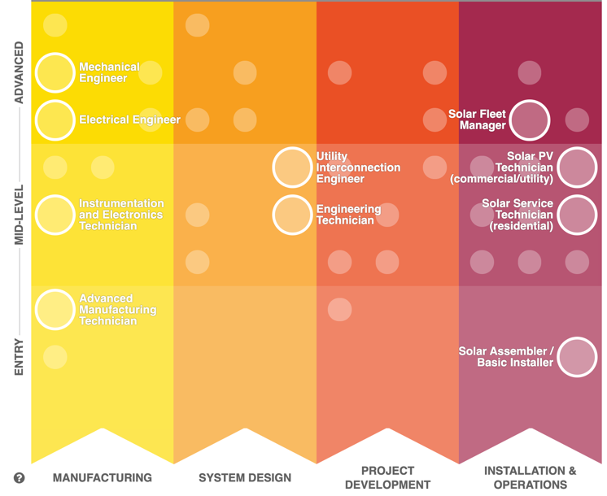Training a trained and skilled workforce enabling the solar industry to meet rising demands for deployment is a top priority. The Solar Energy Technologies Office (SETO) addresses the vital need for high-quality, local, affordable training in design, installation, sales and inspection of solar energy systems, as well as engineering of power systems and related careers such as real estate and finance through a range of training programmes.

# Marketing Analysis

# Swelect Marketing Analysis

Swelect has over 34 years of experience operating in Power Electronics and Power systems market. Swelect acquired HHV Solar technologies (HHSVT) in 2014 to become one of the largest manufacturers of solar PV modules and other solar products. This acquisition has placed Swelect at an advantage to its competitors as it has a fully integrated operations and complete portfolio of products and services across the solar energy market.

The complete marketing analysis of Swelect below is carried out to identify the various product & service offerings and how it is placed as against its competitors.

## Marketing Mix – 7 P’s

1. Products:

**Solar PV Modules:** It produces both Mono- and Poly-crystalline Solar photovoltaic modules designed to provide superior performance even in low-light conditions and work in the toughest of environmental conditions. The modules comply with global quality standards and safety requirements. Below are the salient features of each type of PV modules: -

*Mono-crystalline Module* - Have highest efficiencies (18.42% to 18.53%) and highest power output, and are best suited for residential, utility and industrial applications. It comes in 72 Cell (power range: 340 - 360W) and 60 Cell configurations (power range: 280 - 300W).

*Poly-crystalline Module* - deliver optimum energy output at efficiency range of 16.63% to 17.76% and are best suited for all applications. It comes in 72 Cell (power: 325 - 345W), 60 Cell (power: 265 - 285W) and 36 cell configurations (power: 150 - 165W).

*BIPV Modules* – These are semi-transparent modules for use in commercial buildings complying with green architecture and can be customized as per client's requirements. It comes in 36 Cell Multi-BIPV module (power: 72 – 150W) and 36 Cell Mono-BIPV module (power: 72 – 170W).

**Solar Energy Park:** The company has made 1.1 billion investment in the design, installation and commissioning of its 15 MW solar power park in Chennai. It operates multiple utility grade solar photovoltaic projects in self-owned as well as public-private partnership mode along with state and central governments. Below are the 10 solar power plants operated by the company: 15 MW Solar Power Plant, 10 MW Solar Power Plant, 4 MW Solar Power Plant, 3.5 MW solar power plant, 2 MW Solar Power Plant, 1.65 MW solar power plant, 1.1 MW Solar Power Plant, 1 MW Solar Power Plant (All in Tamilnadu) and 1 in Karnataka - 10 MW Solar Power Plant.

**Roof-Top & Utility Scale solar power installations**: The company has developed rooftop as well as utility scale solar projects at several overseas and across national for various private companies, government, education institutes, Hospitals and residences. Nation’s first ever floating solar power plant project of 100kWp power capacity was executed by SWELECT.

**Solar Water Pump**: Swelect offers easy-to-install Solar water pumps for farmers to counter the erratic grid power supply and expensive diesel pumps. The Solar pumps are available in 4 models and can be used to provide water supply for drinking and agriculture use.

**Other Solar Products:** The company also offers on-grid Solar inverters in 4 models, off-grid Solar inverter also called Solar Power Generator in 2 models, Solar Home systems, LED lighting solutions.

**Service Offerings**: Swelect opened a new vertical named “Solar Energy Storage Solutions” in its endeavor to turn into an energy solutions provider company. The Company offers various services in Energy Conservation and Audits, Site Feasibility Analysis for solar power projects, operation and maintenance of plants, and provides services from design to commissioning as “Engineering, Procurement and Construction” contractor. The complete value chain as EPC contractor is below: -

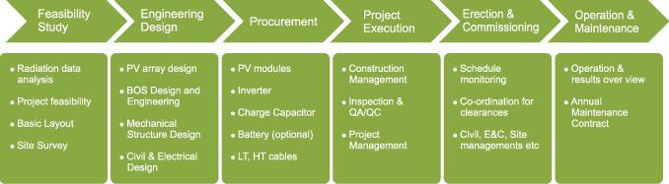

1. Pricing:

**PV Modules**: Monocrystalline modules is more energy efficient than poly-crystalline module and are viewed as premium products. The modules having higher power capacity are more economical and have better efficiency levels as compared to lower capacity modules. Below is the quoted price from various vendors: -

|  |  |  |  |  |  |
| --- | --- | --- | --- | --- | --- |
| **Monocrystalline** | | | **Polycrystalline** | | |
| **Panel Efficiency** | **Power Capacity (W)** | **Approx. Prices/Watt (Rs)** | **Panel Efficiency** | **Power Capacity (W)** | **Approx. Prices/Watt (Rs)** |
| 17% | 250-300 | 47 | 13% | 100-200 | 52 |
| 18% | 250-300 | 48 | 200-250 | 48 |
| 19% | 100-250 | 45 | 14% | 100-200 | 54 |
| 250-300 | 42 | 200-250 | 52 |
|  |  |  | 15% | 100-200 | 48 |
|  |  |  | 200-300 | 39 |
|  |  |  | 16% | 150-200 | 59 |
|  |  |  | 200-300 | 55 |
|  |  |  | 17% | 150-200 | 36 |
|  |  |  | 200-250 | 30 |
|  |  |  | 250-300 | 32 |

The modules available in India are mostly “Polycrystalline”. The price range for solar modules depends on its type but are generally priced between Rs 30 to Rs 60 per watt at peak power generation capacity.

Swelect is facing stiff competition from cheap solar PV modules imported mainly from China. It offers premium solar PV modules that undergo multi-stage, 100% in-line electro luminescence test to ensure they are micro-crack free, with 12-yr performance warranty & 25-year guarantee. The company charges slightly higher than imported panels from China for its panels which provide better performance and comes with excellent after-sales services. The long-term demand position for solar photovoltaic modules is favorable due to its improved tariff as compared to conventional energy sources and policy support from Government of India such as RPO norms, implementation of safeguard duty, renewable energy incentives.

**SOLAR PROJECTS:** For the solar projects, the rates are mostly regulated by the government. SECI fixed solar power rates at Rs 4.5 after a competitive bidding as per provisions of the Electricity Act. The weighted average Capacity Utilization Factor (CUF) is around 17% as on July, 2019. Swelect is trying to renegotiate the weighted average tariff levels for the 10 MW solar power plant in Karur, Tamil Nadu.

**Solar Powered pumps** are priced ideally for farmers in collaboration with Tamil Nadu government at 90% subsidy with 5HP @ Rs. 29,490 & 7.5 HP @ Rs. 48,500.

1. Place:

Swelect provides its products and services centrally operated from the head office in Chennai. It has international offices setup in USA, Europe, Myanmar & Singapore. It also has regional offices which spans across various metro and capital cities in most of the states and has formed dealer network across India.

Swelect and its subsidiary HHV Solar have an online presence which provides an easy access for interested clients to get connected with them and discuss about any related projects. Swelect has designed an online shopping website to give its customers an easy access to their products.

Their investments in solar energy parks are mainly in Tamil Nadu and Karnataka and have installed roof-top installations in various cities across India.

1. Promotion:

Swelect uses online channels like Facebook, Twitter handle and LinkedIn account to advertise mainly on religious festivals or uses the channels to showcase its achievements and contribution to the community. Swelect spends a less amount of money for promotional and advertising activities. This is due to the fact that the company mainly uses and depends on its dealers’ network to reach the last mile. Also, a major portion of their services are associated with solar parks in association with government, which do not need huge investments in advertisements.

The company advertises on World Environment Day, Earth Day, Mother’s Day, to communicate to its customers and the public about maintaining a sustainable model for the environment and community. Swelect uses renewable energy expos like RenewX 2019 for promotional activities. And also advertises its projects with Hospitals or College to gain a good amount of goodwill for the community within which they conduct their businesses.

1. Process:

Swelect has built World class, state-of-the-art facility with installed capacity of 110 MW and follows several processes related to business, electricity generation, customer service to achieve operational efficiency. Its product and services are certified as per internationally recognized standards: IEC 61215/61730 & UL 1703 for better low light performance, IMS certified-ISO 9001:2015, ISO 14001:2015, and BS OHSAS 18001:2007, CEC, MCS-BRE UK, MNRE.

The Company provides solar modules with zero defects 100% multi-level EL tests, cell Chip, visual inspection, Hi-Pot test, insulation resistance, ground continuity test, gel test, peel strength test, adhesion test, wet leakage tests. The raw material is procured from reliable sources after extensive testing through its supply chain and logistics which is managed by highly efficient ERP software. This allows them to offer really long warranty period on its products.

Swelect follows its Quality, Environment, Health & Safety Policy to the heart so as to achieve total customer satisfaction and commit to minimize its impact on the environment. The company follows Six Sigma methodology for improving overall equipment efficiency; follows Lean manufacturing processes to identify and eliminate waste and achieve continuous improvements by following best practices like 5S, Kaizen and Kanban.

1. People:

Swelect understands that its people are an important ingredient to its overall strategy and hires highly qualified and experienced personnel in its team. The company depends on its passionate people for providing excellent services to its customers.

The Company hires India's best PV scientists, engineers and equipment manufacturers in its R&D division to innovate and achieve continuous innovation and development in its technology. The company provides safe and healthy working environment for its employees. The company is very focused on providing best-in-industry training and coaching programs to its technical managers. It encourages its employees by aptly rewarding them and conducts review sessions for continuous skill upgradation and to be creative at work.

1. Physical Evidence:

The company encourages its well-trained commercial managers to provide creative solutions and to think from the customer's perspective. Its managers and personnel working at the manufacturing facility are well dressed as well as the facility is kept dust-free which projects the company’s image of following stringent quality process.

Swelect’s PV module manufacturing facility at Bangalore is fully automated and equipped with state-of-the-art equipment which infuses confidence in its abilities of providing high quality solar products for large commercial clients.

Swelect operates and maintains multiple utility grade solar PV projects at high efficiency levels with state and central government. These projects are proof of the high standards and quality of experience that Swelect can offer to its customers as an EPC solar solutions provider in the various stages of setting up of solar projects of various capacities.

## Segmentation, Targeting & Positioning

Great marketers adapt their offerings to satisfy the customer’s primary pain points. For consumers looking for solar products, the primary pain points are: Utility bills; Rising costs of fuel; Jealousy - If a neighbor gets solar, it’s a symbol of values and a vote of confidence in solar; guilt about emissions and global warming. But many people still perceive investment in solar to be expensive.

Segmentation Analysis of Solar power market:

The solar power market is highly fragmented. The consumers can range in terms of sectors, purpose, project size and connectivity with conventional energy source. The consumer can be from varied sectors - from corporate sector, retail shops, beauty salons, fast food chains, educational institutes, real estate developers, residential societies, farmers, etc.

Solar PV modules are suited for both residential as well as commercial consumers. Solar power market can be **segmented by size of end-user**: -

1. **Residential or Domestic consumers** – domestic user usually go for small scale roof-top solar, solar home solutions, solar powered LED lighting systems for residential societies. Farmers and small Villages are also interested in solar powered water pumps, solar power street lighting solutions.
2. **Commercial consumers** – commercial institutions opt for small or mid-size roof-top solar power projects to meets its needs.
3. **Utility Scale Projects** **for Government** – The utility projects are built on very high scale to generate and provide solar power for captive consumer. These projects are developed in public-private partnership with state or central government.

The combined capacity of all rooftop solar projects in India has grown past 1 GW. The utility segment has the maximum market share of 87% in India’s solar power in 2018. The adoption of utility-scale solar power by both central and state government will help in minimizing the cost of solar PV technology. So, we expect the utility segment to continue to dominate the market for the coming years as well.

The solar power market can also be **segmented by application**: -

1. **Grid-connected** – It does not use batteries but only an inverter. Grid-connected systems are administered by a policy involving ‘net metering’. The system records the extra solar power generated than home usage and is fed to the grid to help earn revenue and any shortfall is made up by the conventional grid.
2. **Off-grid** - It is a stand-alone system which is not connected to the main grid. Solar energy generated is stored in batteries and then converted into AC power by an inverter for home usage.

The various factors such as declining solar power tariffs, favorable policies by both central and state-level governments is helping the grid-connected segment to achieve higher market share in India’s solar power market. The grid-connected segment is at approximately 97% of the market share, and is expected to dominate the market for coming years.

Targeting:

The targeting strategy of Swelect is differentiation by providing solar panels which are more durable, provide better efficiencies even in low light situations and have guaranteed performance at a certain level of power generation capacity. The target segments for Swelect are:

1. Solar Power generation companies.
2. Commercial institutions, Colleges, Hospitals, companies looking to enhance green image and reduce their utility bills.
3. Agriculture farmers and farm owners with want of solar powered water pump due to frequent breaking of conventional power supply.
4. Home owners, environmentalists for solar water heaters, solar LED, complete solar home solutions.

The company understands that everyone will not be able to afford the better solar products, but it provides various options, and the consumers who want the best products will always prefer it for premium quality products. Swelect provides information about its products and services on websites, social media, various solar expos in order to attract both commercial as well as domestic clients.

Positioning by Swelect:

Swelect has achieved high brand recall value by providing to its consumers, the premium and reliable solar PV modules that have high performance for long periods. Its products are used in various small to high volume requirements and in wide range of industrial and consumer goods and services, across both grid-connected and off-grid applications. Its positioning statement is:

**“SWELECT energy systems provide sustainable energy solutions for a greener India.”**

* Striving towards a cleaner environment.
* We tap the sun every day on our roof.
* Smartest energy choice under the sun
* Buildings that generate free clean electricity, thanks to BIPV.

## Ansoff Matrix

Ansoff matrix is a growth strategy matrix that can be used by the businesses by looking at its products to identify alternative growth strategies. The 4 growth strategies are: market penetration strategy; market development strategy; product development strategy; and lastly product diversification strategy.

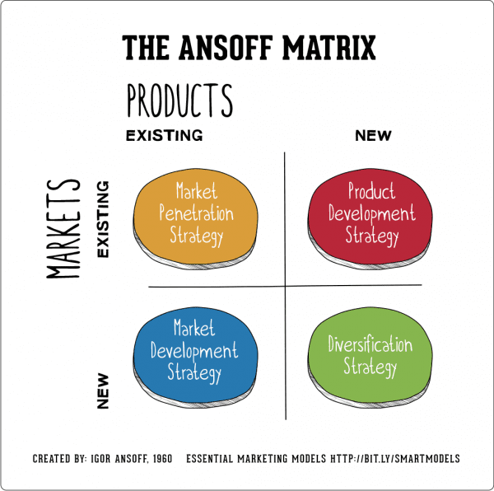The growth strategies employed by Swelect are:

* Online website for homeowners, and domestic clients to purchase solar products online from the comfort of their home.
* The company has fully backward integrated supply chain to deliver maximum value to consumers.
* Launched Mono PERC SPV module with international certifications in market.
* The company is targeting new international geographic markets from its international office in Malaysia.
* It has added solutions and services vertical to cater to the needs of consumers seeking services in various stages of solar plant installations.
* It is providing a host of value-added services like concept designing, operations & maintenance, etc. as EPC contractor.

The company has setup utility scale power plants only in Tamil Nadu and Karnataka. IT can also set up solar plants in other states with better solar rating index.

## BCG Matrix

Boston Consulting Group Matrix classifies the various products offered by the company in its portfolio based on their performance as Stars, Cash Cows, Dogs and Question Marks.

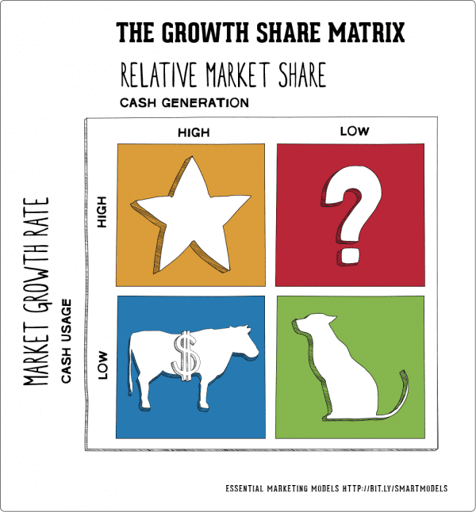Based on the above BCG matrix, the various products in Swelect portfolio can be categorized as below: -

**Dogs**: None of its products or services are bleeding.

**Question marks**: Domestic Rooftop Solar Projects; Solar Energy Solution Services.

**Star Products**: Swelect has solar products like Solar PV Modules, Solar Water Pumps, Invertors, etc.

**Cash cows**: Utility Scale Power Projects since we see steady income from sale of power.

# Adani Green (Adani Solar) Marketing Analysis

Adani Green installs solar power projects as EPC contractor as well as its subsidiary Adani Solar is a manufacturer of the Solar PV panels. Adani Solar is India’s first and largest vertically integrated solar company that offer products along with services across the spectrum of photovoltaics manufacturing. The cutting-edge technology, with machinery and equipment from the finest manufacturers in the world, seeks to assist in cost leadership, operational efficiency and performance quality according to global standards. Unique positioning through third party certifications:

* The Company is awarded Top Performer by DNV-GL PVEL Global reliability testing for two consecutive years (2018 & 2019).
* Adani Solar manufacturing facility is awarded Platinum-rated by Indian Green Building Council.
* Factory audited by Reputed independent agencies such as Black & Veatch
* Only Indian company with IEC 2016 certification in all Stock Keeping Unit

## Marketing Mix – 4 P’s

1. Products & Services:

Products available areEncore (Multi crystalline), Eternal (Mono PERC) & Elan (Bi-facial Products)

Solar EPC and Rooftop solar services as solutions provider.

SOLAR EPC and ROOF TOP:Adani Solar is one of the leading turnkey EPC players in the Indian PV solar industry. It has an experienced in-house design, engineering and construction team that, with its technical expertise and in-depth industry know-how, can develop the most cost-effective and energy efficient PV solar plants of any scale. Total EPC Solutions Adani Solar's systematic and integrated approach enables it to execute large-scale solar power projects in India and overseas on time, every time. Its team of experts help clients understand the financing, policies, land, fiscal benefits, and regulatory approvals required for successful installation and execution of these projects.

From concept to execution, it provides end-to-end solutions: Adani Solar has the prowess to manage solar energy projects of any scale and deliver turnkey projects across utility sectors, rooftop, or special projects like floating solar plants, BESS, mini and micro-grids. Its presence across the value-chain not only ensures superior designed plant, but reliable project execution as well, right from strategic planning to use of latest technology.

**Approach:**

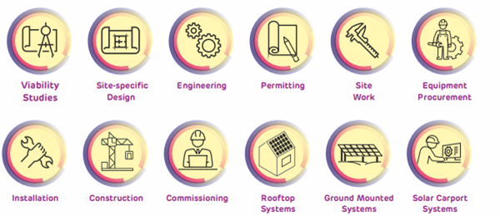

Adani’s Solar Modules:

Adani Solar's cutting-edge technology, scale of operations, cost leadership and reliability, sets it apart from all other global competitors and supporting utilities. Adani Solar produces hi-tech solar panel modules using advanced technology and supplies reliable solar modules that are proven to meet the customer's exact requirements.

A solar photovoltaic (PV) system mounted on a rooftop of a building is a mini-power plant that converts solar energy into electricity to meet the property's power requirements or feed into the grid. With a mission to electrify every household in India by harnessing the power of the Sun, Adani Group, one of India's largest private power producers, brings to you Adani Solar, India's largest Solar Cell and Module Manufacturing Company with a capacity of 1.2 GW. It is one of the fastest growing roof-top and distributed solar EPC Company with over 250 MW projects commissioned and 400 MW under execution in over four continents. Adani Solar is India's first company with vertically integrated businesses that offers services across the spectrum of photovoltaics manufacturing. Its state-of-the-art manufacturing facility located in Mundra has multi-level infrastructure and is optimized for scaling up to 3 GW of modules and cells under one roof. It produces high efficiency Multi, Mono PERC and Bifacial Modules which promise higher performance and enhanced reliability.

|  |  |  |  |
| --- | --- | --- | --- |
| **Commercial Name** | Encore Series | Eternal Series | Elan Series |
| **Category** | Multi-crystalline P-Type | Mono-PERC P-Type | Bifacial N-Type / P-Type |
| **Features** | For higher efficiency and better rates of return. Ideal for Utility scale project. 330 to 340Wpp | For large-scale and rooftop PV installations, 360 to 390 WP | Lowest LCOE and Highest IRR with 30 years warranty, 355 to 385WP |

1. Process:

|  |  |
| --- | --- |
| **Rooptop & Distributed Solar EPC Business Model** | |
| In CAPEX (Capital Expenditure) business model for solar deployment, the customer buys the solar PV system by making 100% of the payment in advance or by financing the system through a bank. | In OPEX (Operational Expenditure) model, the Renewable Energy Service Company (RESCO) developer invests in solar rooftop asset and sells the generated power to the building owner in favor of low solar power tariff. The excess power may be sold by the owner to the utility according to the power purchase agreement through net metering system. |

**EPC- Services:**

|  |  |  |
| --- | --- | --- |
| **Engineering- E** | **Procurement -P** | **Construction-C** |
| • Yield assessment • Basic planning and engineering design • Selection of components basis quality norms • Finalization of design • Construction design (detailed engineering | • Specifications • Bid comparisons • Preparation of Contract • Purchase of modules | Preparation of installation and construction documentation • Specialist risk management • Specialist site management • Logistics co-ordination • Safety co-ordination • Commissioning and performance testing • Experienced project management and detailed documentation |

1. PRICING:

Adani solar is considered as the Tier 1 bankable module manufacturer with 25-year history. The solar panels have torsion and corrosion resistant with anodized aluminum frame to face wind and snow. Adani solar panels are highly efficient and minimize losses, better module protection. Electroluminescence tested for micro cracks in Adani solar Panels. The Solar panels are highly reliable with rating IP67 and of good quality tagged with the brand name Adani come in different output power capacity and are priced between Rs 25 to Rs 32 per watt.

1. PLACE:

Adani Solar is subsidiary of Adani Green and is India's largest Solar PV Cell and Module Manufacturer with 1.2 GW capacity at Mundra. It is the fastest growing Rooftop and distributed solar EPC company with projects over 250 MW commissioned and over 400 MW under execution. Adani Solar is India's first company with vertically integrated businesses that offers services across the spectrum of photovoltaics manufacturing. Its solar panels come in different types - Multi, Mono PERC and Bifacial modules with superior efficiency, higher performance and enhanced reliability. It maintains market leadership, as it is the first manufacturer in India with IEC 2016 certification in all SKUs. It is accredited as Tier-1 supplier by BNEF and is the only Indian manufacturer to be awarded Top Performer by DNV-GL & PVEL Global reliability testing consecutively for two years 2018-19.

Business Models

Supply and Install Business

The companies involved in Supply and Install Businesses deal primarily with home owners and companies who want to increase their Green Power footprint and also reduce their utility power bills. The financing requirements are higher in the initial stages of project implementation. Fixed prices model for Turnkey implementations are generally used.

Own-and-Operate Model

Under the Own-and-Operate Model model, the company supplies, install, own and operate the solar power system located on the roof or property of their customer. The customer agrees to purchase the electricity the system generates at a given rate over a certain period, typically 10 years or longer. This business model is attractive because the customer enjoys a guaranteed electricity rate without assuming any risk. As owner, one can take advantage of subsidies to make your project more attractive.

Solar Farm Installation

Another version of the own-and-operate model is to build a solar farm where a business installs a large number of solar panels in a sunny location on land that they own or lease. Before they start, they need an agreement with the local utility to buy your power and integrate it into the grid. The advantage of this model is that you have full control over the solar installation's location and orientation. Rather than being restricted to existing roof lines, you can install the panels at the optimum angle and facing in a direction for maximum exposure to the sun.

The Investor-Owned Model

Often companies that supply and install the solar panels don't want to own and operate the system, or they may not have the financial resources to own a large number of installations. Instead, companies backed by investors negotiate power purchase agreements with utilities, consumers or businesses to buy the power produced, and hire supply-and-install companies to build the systems. The investor-backed companies own the solar power systems and achieve the desired rate of return from the power sales and from subsidies. You can use this model to successfully address solar power financing issues.

Cartelization Attempt

In 2018, Solar Energy Corporation of India (SECI) partially cancelled the country’s largest-ever solar power auction. The fact that SECI had offered 3 gigawatts of capacity in one go was a milestone in India’s solar power sector. Several developers — Indian and foreign — had collectively offered to set up 10.3-gigawatt capacity. The cancellation was a major hit for SB Energy, the joint venture company between SoftBank, Bharti Enterprises, and Foxconn Technologies. SB Energy has pledged to invest $20 billion to set up 20 gigawatts of solar power capacity in India. The cancellation of 2.4 gigawatts of the 3-gigawatt capacity was done because SB Energy had formed a cartel with other project developers with a likely motive to collectively quote higher tariff bids.

Innovations

Light Sensitive Nanoparticles:

It is a technology that aims at providing more flexible and affordable materials for solar cells. The new materials suggested uses n-type and p-type semiconductors; however, these can actually be functional outside, something which was a challenge in the previous designs. Discovered by researchers at the University of Toronto, these new colloidal quantum dots do not bind to air and hence are able to maintain stability outside. This works for harnessing solar power because the radiant light absorption is much higher here. Basically, panels that use this technology are estimated to be nearly eight percent more efficient in the conversion of sunlight.

Bifacial Solar Modules:

Unlike the mono facial solar panels that have been used, by and large, bifacial modules produce solar power efficiently from both sides. When a bifacial module gets installed on a highly reflective surface, such as a white TPO roof or on a ground which has light-colored stones, it can produce a lot more energy as compared to a mono facial solar panel. It is estimated to increase about 30% production just from the amount of extra power generation in the rear side of the module. Bifacial modules actually come in many different designs. While some can be framed, some are frameless. There are options of clear back sheets and dual glass here. The design that should be adopted depends upon the requirements.

Thin Film Solar:

Solar films can be printed in rolls, which do not only reduce the cost but also open new possibilities of placing solar power in different places.

Hairy Solar Panels:

This type of solar panel uses the core of nanotechnology wherein light-absorbing nanowires are combined with carbon nanotube fabric. These nanowires can help in better absorption energy as compared to silicon, which may help in a more efficient solar energy harvesting.

Solar Windows:

Solar windows are mainly treated with a new electricity generation coating which remains transparent and yet has the ability to convert sunshine into solar power. The coating of these solar windows has the ability to produce the smallest functional solar cells in the world.

Floating Solar Panels:

There are many countries that are battling small spaces in order to mount solar systems. Since authorities find it challenging to put ground mount solar systems, especially in large farmland areas, more and more companies are coming up with ecological alternatives. One such innovation is a Floating Solar Panel. This is adequate for industries that operate closer to water bodies or have a large requirement of water. Placing the panels in water helps in a natural cooling process and reduces the wear and tear of the panels.

Investing as a Solar Equipment Manufacturer

|  |  |  |  |  |  |
| --- | --- | --- | --- | --- | --- |
| **S.N.** | **Factor to be considered** | **Weightage %** | **Invest** | **Don’t Invest** | **Justification for the score** |
| **1** | Capital investment required (minimum) | 7% | 4 | 6 | Medium level of investment in Solar Equipment manufacturers and assembly due to investment in PV module factory. |
| **2** | Working capital requirements | 9% | 7 | 3 | Long operating cycle ranging 3 months to 9 months. Requires efficient management and use of better bargaining power of suppliers and distributors. |
| **3** | Profitability in terms of Profit margin/operating profit margin | 10% | 7 | 3 | Good operating profit margin of 9% signifies companies who are operationally better can give better returns. |
| **4** | Profitability in terms of ROE | 9% | 7 | 3 | The segment gives nice returns of 21% on equity. |
| **5** | Market structure | 9% | 6 | 4 | The market is an oligopoly with multiple competitors |
| **6** | Ease of entry and doing business | 8% | 7 | 3 | Requires huge capital investment, but availability of imported solar modules lowers the cost considerably. |
| **7** | Competitive Pressures | 9% | 4 | 6 | High competitive pressure due to proliferation of both domestic, multinational and smaller regional players. Industry is quite fragmented. |
| **8** | Governmental regulations and controls | 7% | 8 | 2 | Lot of government subsidies, and policy programs to shift to green energy. |
| **9** | Marketing issues | 9% | 7 | 3 | Energy expo's and social media help in connecting manufacturers with the audiences |
| **10** | HRM issues | 4% | 4 | 6 | Training and hiring personnel to perform R&D activities are difficult to find. |
| **11** | Manufacturing process issues | 6% | 7 | 3 | The panels are sourced mostly from China and other East Asian countries and assembled in India |
| **12** | Operational issues – SCM | 6% | 4 | 6 | Natural Degradation of solar panels leads to high maintenance costs. |
| **13** | Collaboration / foreign investment or funding | 3% | 9 | 1 | A 100% FDI in solar sector under automatic route in projects of renewable power generation and distribution |
| **14** | Innovations possible | 6% | 6 | 4 | Innovations are fast paced and technology changes continually. Manufacturers need to be adept to the changes |
|  | FINAL DECISION | 100% | **6.21** | **3.79** | **Invest** |

|  |  |  |  |  |  |
| --- | --- | --- | --- | --- | --- |
| **S.N.** | **Factor to be considered** | **Weightage %** | **Invest** | **Don’t Invest** | **Justification for the score** |
| **1** | Capital investment required (minimum) | 10% | 4 | 6 | Heavy investment in TurnKey project developers. |
| **2** | Working capital requirements | 10% | 5 | 5 | Long operating cycle ranging 3 months to 1 year. Requires efficient management of suppliers and distributors. |
| **3** | Profitability in terms of Profit margin/operating profit margin | 8% | 3 | 7 | Low operating profit margin of 3% signifies companies are not able to put a lid on their costs. |
| **4** | Profitability in terms of ROE | 8% | 7 | 3 | The segment gives nice returns of 35% on equity. |
| **5** | Market structure | 9% | 5 | 5 | The market operates in an oligopoly structure with multiple competitors |
| **6** | Ease of entry and doing business | 8% | 3 | 7 | Required huge capital investment, political influence to enter into turnkey project developer segment. |
| **7** | Competitive Pressures | 6% | 4 | 6 | High competitive pressure due to proliferation of both domestic, multinational and smaller regional players. Industry is quite fragmented. |
| **8** | Governmental regulations and controls | 8% | 7 | 3 | Lot of government subsidies, and policy programs to shift to green energy. |
| **9** | Marketing issues | 7% | 7 | 3 | Government acts as promoter by starting schemes like JNNSM and FAST apart from other saur urja shops |
| **10** | HRM issues | 4% | 8 | 2 | The labour to install and deploy turnkey solar projects are easy to find and deploy. Engineers trained with necessary skills to run and managers to manage can be hired |
| **11** | Manufacturing process issues | 6% | 6 | 4 | Manufacturing is still concentrated in a single territory. Policies to restrict imports and manufacture locally are promoted by government |
| **12** | Operational issues – SCM | 6% | 6 | 4 | Operational issues when implementing projects are mitigated by government regulations. |
| **13** | Collaboration / foreign investment or funding | 7% | 7 | 3 | Markets have been opened for FII's bringing in investments from international players |
| **14** | Innovations possible | 4% | 5 | 5 | There is a limited scope of innovations. Established practices used for setting projects and power transmission |
|  | FINAL DECISION | 100% | **5.34** | **4.63** | **Invest** |

Investing as a Turnkey Project Implementor

Conclusion

India Government has set a target of 100 GW of installed solar capacity by 2022. As on June 2019, India has managed to achieve 31.5 GW of solar RE capacity which is far behind the target of 48GW set for March 2019. There is reversal in the growth of installed solar capacity and delay in solar projects mainly due to various duties on solar equipment and the associated uncertainty has led to a short-term uptick in solar prices. This has led to delays in solar projects and even recent cancellation of auctions which risks jeopardising investor confidence.

The government has been swift and flexible at responding to various industry hurdles and are helping reduce project risks. As a result, solar energy prices continue to remain competitive. We expect this short-term decay in installed solar capacity to rebound in the next few quarters as the imposed duties gets completely removed. This will help both the solar manufacturers as well as Turnkey solar power plant project implementors to return to profitable ways.

Swelect has converted into a solar energy solutions and services provider which has opened a profitable revenue stream for the company. Adani Green has also ventured into solar panels and other solar products through its subsidiary Adani Solar to open up another revenue stream for itself.

The companies Swelect and Adani Green are well placed in their respective segments to benefit from this growth. The management of both companies must effectively manage their operational cost in the direction of maximizing their profits. Adani Green should also look in restructuring their finances to limit their losses due to higher finance cost.